**Henrique Monteiro, 8º Turma, Projeto final**

**Tarefa 1: Testando a Teoria**

1. Link para a planilha do Google:

[Henrique Monteiro, 8º Turma, projeto final.xlsx](https://docs.google.com/spreadsheets/d/1upntolg25n5Wx7Mt3UWJ-Qmyjf6dUwA5/edit?usp=sharing&ouid=105840637536928126724&rtpof=true&sd=true)

**Tarefa 2: Aplicativo Web Urban.Scooter**

1. Mapa mental (opcional):

LINK: [Mapa Mental](https://drive.google.com/file/d/1jGHN7-4xRM6nhzVvvAkhpEQb0g89rVKi/view?usp=sharing)

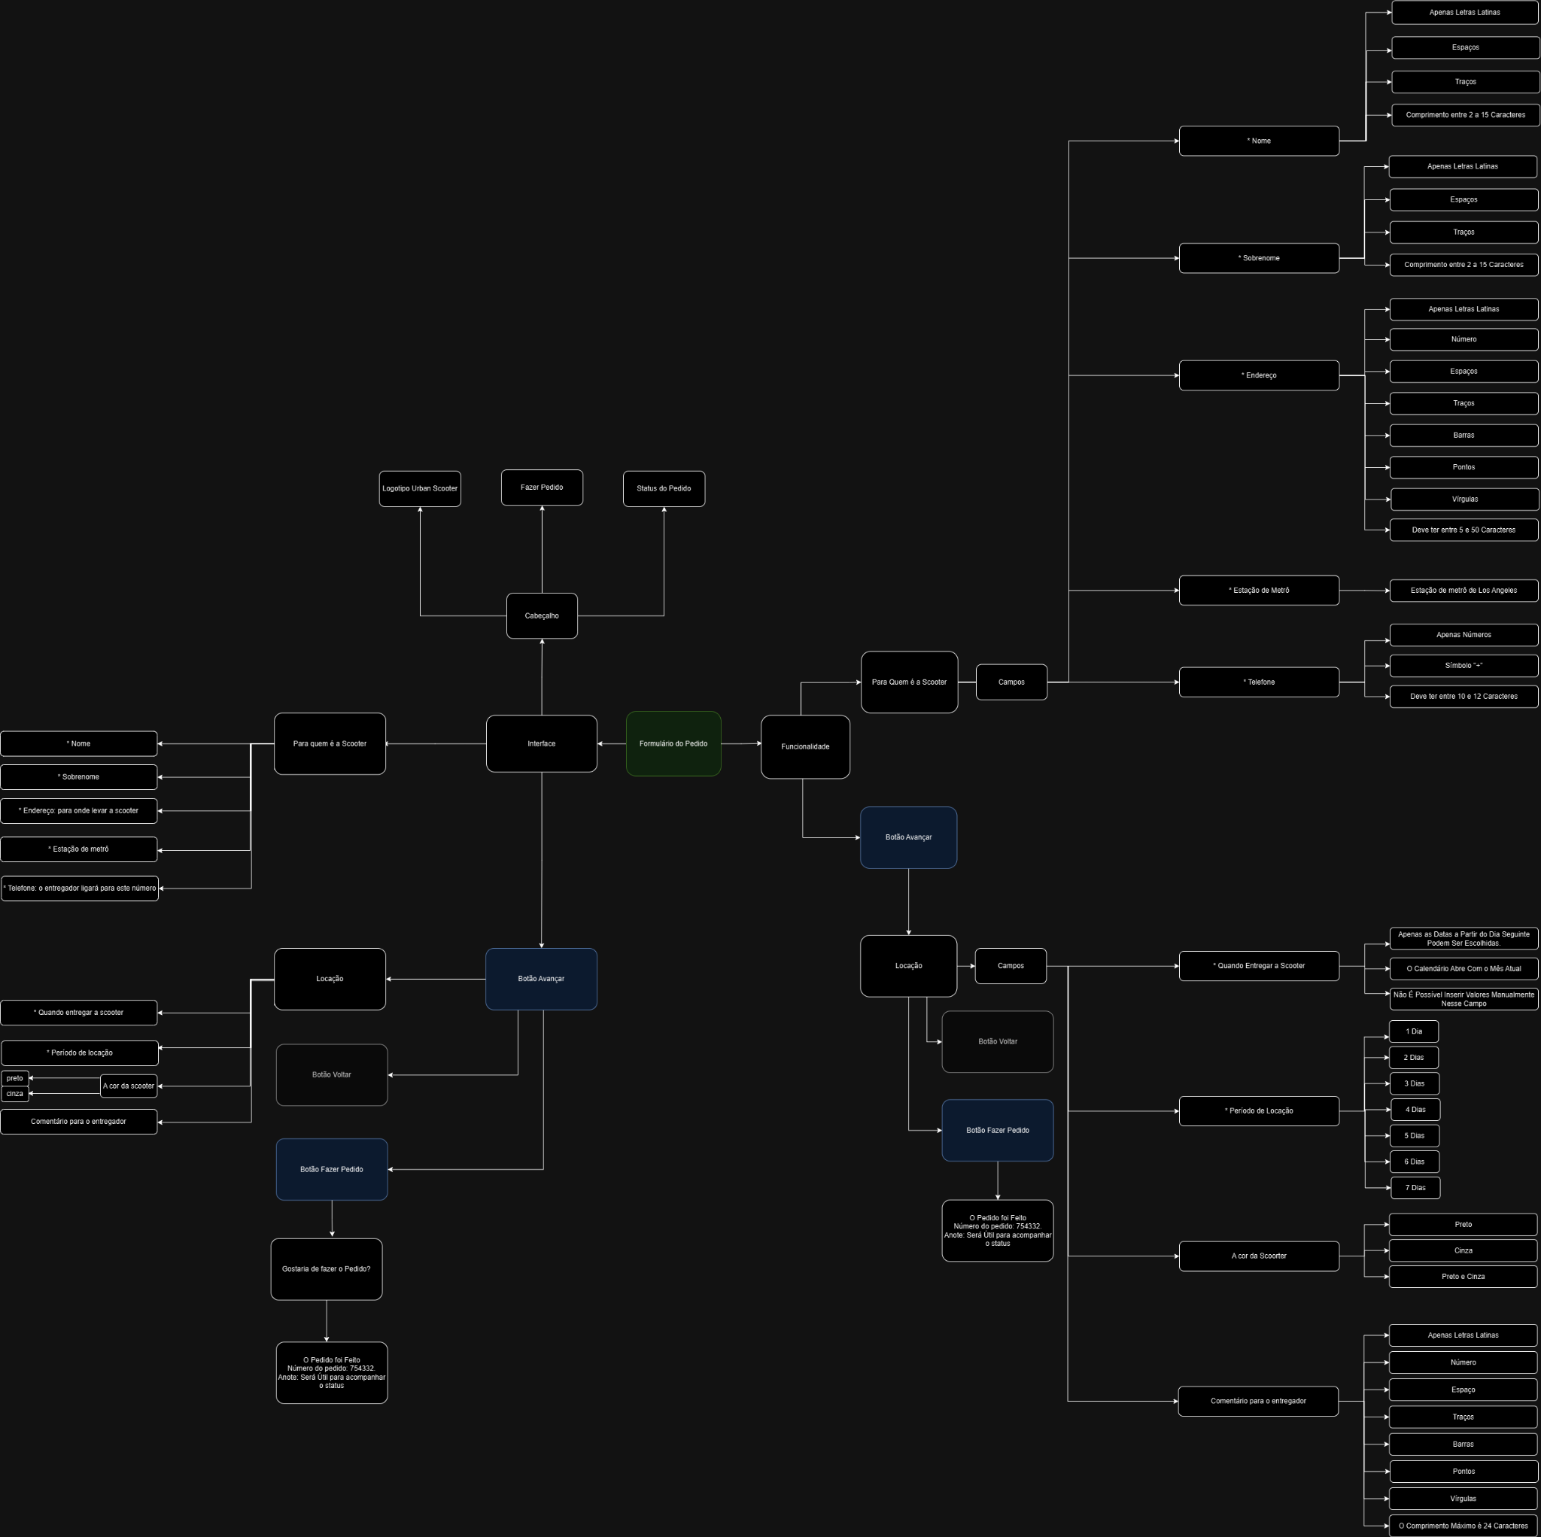

1. Links para os relatórios de bugs feitos no Jira:

LINK: [JIRA - Relação com todos os BUGS](https://hm-projetos.atlassian.net/jira/software/c/projects/FNQ8/list?atlOrigin=eyJpIjoiOTBiNGEzN2Q1ZjFlNDJhMWFhZWNmODYyZjBmMjQwZTQiLCJwIjoiaiJ9)

**Tarefa 2: Lista de Verificação**

<https://hm-projetos.atlassian.net/browse/FNQ8-1>

<https://hm-projetos.atlassian.net/browse/FNQ8-2>

<https://hm-projetos.atlassian.net/browse/FNQ8-3>

<https://hm-projetos.atlassian.net/browse/FNQ8-4>

<https://hm-projetos.atlassian.net/browse/FNQ8-5>

<https://hm-projetos.atlassian.net/browse/FNQ8-6>

<https://hm-projetos.atlassian.net/browse/FNQ8-7>

<https://hm-projetos.atlassian.net/browse/FNQ8-6>

<https://hm-projetos.atlassian.net/browse/FNQ8-7>

<https://hm-projetos.atlassian.net/browse/FNQ8-8>

<https://hm-projetos.atlassian.net/browse/FNQ8-10>

<https://hm-projetos.atlassian.net/browse/FNQ8-11>

<https://hm-projetos.atlassian.net/browse/FNQ8-12>

<https://hm-projetos.atlassian.net/browse/FNQ8-13>

**Tarefa 2: Dados de Validação**

<https://hm-projetos.atlassian.net/browse/FNQ8-14>

<https://hm-projetos.atlassian.net/browse/FNQ8-15>

<https://hm-projetos.atlassian.net/browse/FNQ8-16>

<https://hm-projetos.atlassian.net/browse/FNQ8-17>

<https://hm-projetos.atlassian.net/browse/FNQ8-18>

<https://hm-projetos.atlassian.net/browse/FNQ8-19>

<https://hm-projetos.atlassian.net/browse/FNQ8-20>

<https://hm-projetos.atlassian.net/browse/FNQ8-21>

<https://hm-projetos.atlassian.net/browse/FNQ8-22>

<https://hm-projetos.atlassian.net/browse/FNQ8-23>

<https://hm-projetos.atlassian.net/browse/FNQ8-24>

<https://hm-projetos.atlassian.net/browse/FNQ8-25>

<https://hm-projetos.atlassian.net/browse/FNQ8-26>

<https://hm-projetos.atlassian.net/browse/FNQ8-27>

<https://hm-projetos.atlassian.net/browse/FNQ8-28>

<https://hm-projetos.atlassian.net/browse/FNQ8-29>

<https://hm-projetos.atlassian.net/browse/FNQ8-48>

<https://hm-projetos.atlassian.net/browse/FNQ8-31>

**Tarefa 3: API do Aplicativo Urban.Scooter**

1. Links para os relatórios de bugs feitos no Jira:

LINK: [JIRA - Lista Geral com todos os BUGS](https://hm-projetos.atlassian.net/jira/software/c/projects/FNQ8/list?atlOrigin=eyJpIjoiOTBiNGEzN2Q1ZjFlNDJhMWFhZWNmODYyZjBmMjQwZTQiLCJwIjoiaiJ9)

**Tarefa 3: Lista de Verificação**

<https://hm-projetos.atlassian.net/browse/FNQ8-32>

<https://hm-projetos.atlassian.net/browse/FNQ8-33>

<https://hm-projetos.atlassian.net/browse/FNQ8-34>

<https://hm-projetos.atlassian.net/browse/FNQ8-35>

<https://hm-projetos.atlassian.net/browse/FNQ8-36>

<https://hm-projetos.atlassian.net/browse/FNQ8-37>

<https://hm-projetos.atlassian.net/browse/FNQ8-38>

<https://hm-projetos.atlassian.net/browse/FNQ8-39>

<https://hm-projetos.atlassian.net/browse/FNQ8-40>

<https://hm-projetos.atlassian.net/browse/FNQ8-41>

<https://hm-projetos.atlassian.net/browse/FNQ8-42>

<https://hm-projetos.atlassian.net/browse/FNQ8-43>

<https://hm-projetos.atlassian.net/browse/FNQ8-44>

<https://hm-projetos.atlassian.net/browse/FNQ8-45>

<https://hm-projetos.atlassian.net/browse/FNQ8-46>

<https://hm-projetos.atlassian.net/browse/FNQ8-47>

<https://hm-projetos.atlassian.net/browse/FNQ8-48>

<https://hm-projetos.atlassian.net/browse/FNQ8-49>

<https://hm-projetos.atlassian.net/browse/FNQ8-50>

<https://hm-projetos.atlassian.net/browse/FNQ8-51>

<https://hm-projetos.atlassian.net/browse/FNQ8-52>

<https://hm-projetos.atlassian.net/browse/FNQ8-53>